

Department of Computer Engineering

# BRACT’s Vishwakarma Institute of Technology

**(An autonomous institute affiliated to Savitribai Phule Pune University)**

# Pune – 411037

*Classification of EEG Signals for Autism Diagnosis: A Machine Learning Approach*

Research Internship project report for:

Vishwakarma Institute of Technology, Pune

# By : Pradyumn Patil (GRN No. 11911229)

Mentored by: Saraswati Patil



Department of Computer Engineering

# BRACT’s Vishwakarma Institute of Technology

**(An autonomous institute affiliated to Savitribai Phule Pune University)**

# Pune - 411037

**CERTIFICATE**

This is to certify that the project report titled “Classification of EEG Signals for Autism Diagnosis: A Machine Learning Approach” by Pradyumn Narendra Patil (GRN No. 11911229) is approved by me for submission. Certified further that, to the best of my knowledge, the report represents the work carried out by the student as a part of his internship during the academic year 2022-23 semester II.

|  |  |  |
| --- | --- | --- |
| College Mentor: | External Examiner:  (College mentor ) | Head of Department: |
| Prof. Saraswati Patil | <name> | Prof.(Dr.) Sandip Shinde |

Date:10th MAY 2023

# ACKNOWLEDGEMENT

I would like to express my sincere gratitude to everyone who has supported me throughout this research project.

Firstly, I would like to thank my supervisor Prof. Saraswati Patil for providing me with valuable guidance, insightful feedback, and encouragement throughout the entire research process. Your expertise, patience, and dedication have been truly instrumental in shaping my research project and helping me achieve my goals.

I would also like to extend my thanks to the Vishwakarma Institute of Technology, Pune for providing me with access to the necessary resources and facilities, without which this research would not have been possible.

Additionally, I would like to thank all the professors who generously gave their time and shared their experiences with me. Your contributions were invaluable in helping me gain a deeper understanding of the topic and in providing rich data for analysis.

Finally, I want to express my gratitude to my family and friends for their unwavering support and encouragement throughout my academic journey. Your love and encouragement have been my constant source of strength and motivation.

**CONTENTS**

* Abstract
* Overview of the topic
* Literature Survey
* Problem Statement
* Objectives
* Proposed Methodology
* Results and discussion
* Conclusion
* Future Scope
* References
* Research Paper publication details

# ABSTRACT

This study aimed at developing a machine learning-  
based approach for the classification of electroencephalography  
(EEG) signals to aid in the diagnosis of autism spectrum disorder  
(ASD). The study used a dataset comprising EEG signals  
collected from individuals with ASD and typically developing  
individuals. Feature extraction techniques were employed to  
extract relevant features from the EEG signals, which were then  
used as input for the machine learning algorithms. The results  
showed that the proposed approach was able to classify EEG  
signals with high accuracy, sensitivity, and specificity. The study concludes that the proposed approach has the potential to be  
used as an effective tool for the diagnosis of ASD.

# Overview of the topic

Autism Spectrum Disorder (ASD) is a neurodevelopmental  
a disorder that affects social interaction, communication, and  
behavior. The diagnosis of ASD is currently based on behavioral  
assessments, which can be subjective and time-consuming.  
There is a growing interest in using physiological measures,  
such as electroencephalography (EEG), to aid in the diagnosis  
of ASD. EEG signals have the potential to identify patterns  
that are associated with the disorder, which can be used to  
develop objective and efficient diagnostic tools.  
One way to analyze physiological features such as EEG  
signals are through machine learning algorithms. Machine  
learning algorithms can learn from patterns in the data to  
accurately classify new data based on the features extracted.  
One common approach is one label classification, which  
involves classifying a set of data into one of two categories  
based on a single label. In the context of ASD diagnosis using  
EEG signals, one label classification could involve classifying  
EEG signals as either indicating the presence of ASD or not.  
However, the analysis of EEG signals is challenging due  
to the high dimensionality, variability, and noise in the data.  
Machine learning algorithms such as Support Vector Machines  
(SVMs), Artificial Neural Networks (ANNs), and Random  
Forests (RFs) have gained popularity for their ability to classify  
complex data. These algorithms can be trained on a dataset  
of EEG signals from individuals with ASD and typically  
developing individuals to identify patterns that distinguish the  
two groups.

To develop an effective machine learning-based diagnostic  
tool for ASD using EEG signals, relevant features need to be  
extracted from the data. Feature extraction techniques such as  
time-frequency analysis and wavelet transformation can be used  
to extract meaningful features from the EEG signals. These  
features can then be used as input for the machine learning  
algorithms, which can learn from the patterns in the data to  
accurately classify new EEG signals.  
Overall, the analysis of physiological features such as EEG  
signals using machine learning algorithms has the potential to  
aid in the diagnosis of ASD. By extracting relevant features and  
using one label classification, machine learning algorithms can  
accurately classify EEG signals and identify patterns that are  
associated with the disorder. This approach has the potential to  
provide an objective and efficient diagnostic tool for ASD,  
which could improve early detection and intervention for  
individuals with the disorder.

# Literature Survey

|  |  |  |  |  |  |
| --- | --- | --- | --- | --- | --- |
| **Sr**  **no.** | **Title** | **Name of author** | **year of publication** | **specifications** | **conclusion** |
| [**1**](https://www.sciencedirect.com/science/article/pii/S0208521617301973?casa_token=xOxZ2YUpnPYAAAAA:votdCzBcwaqrOYEgxXrAqRyqkAUdmrOUPo-Qh0mjIihVpBsf26_LNo-fK9wzaxKx8TSAr9pDL4I) | **Electroencephalography (EEG) signal processing for epilepsy and autism spectrum disorder diagnosis** | **Sutrisno Ibrahim, Ridha Djemal, Abdullah Alsuwailem** | **(2018)** | **Technique :- DWT, Shannon entropy, and k-nearest neighbor (KNN)**  **accuracy :-  94.6%** | **This study investigates using different EEG feature extraction and classification techniques to diagnose epilepsy and autism spectrum disorder. They preprocess the EEG signal, use DWT to decompose it into sub-bands, and measure complexity and synchronization between channels.** |
| [**2**](https://direct.mit.edu/neco/article-abstract/33/7/1914/100580/Classification-of-Autism-Spectrum-Disorder-From) | **Classification of Autism Spectrum Disorder From EEG-Based Functional Brain Connectivity Analysis** | **Noura Alotaibi, Koushik Maharatna** | **(2021)** | **Technique :-  cubic support vector machine (SVM)**  **accuracy :- 95.8** | **This study used EEG and machine learning to classify children with autism and typical children. The functional brain connectivity networks were characterized using graph-theoretic parameters, and the study successfully classified the two groups with 95.8% accuracy.** |
| [**3**](https://www.sciencedirect.com/science/article/pii/S0010482520301074?casa_token=d5aSItngnl0AAAAA:CUKD0IK51MX31vv6GDvTXSU0i2X3phlOFrpVLCreQ9Fxl06rnJHOeNkREeFdzEiyGghCDeln1sA) | **The identification of children with autism spectrum disorder by SVM approach on EEG and eye-tracking data** | **Jiannan Kang a, Xiaoya Han b, Jiajia Song a, Zikang Niu c, Xiaoli Li** | **(2020)** | **Technique:- MRMR) feature selection method combined with SVM classifier**  **accuracy :- 85.44%** | **This study used EEG and eye-tracking features as input to a machine learning approach to identify autistic children. The study enrolled 97 children aged 3 to 6 and used MRMR feature selection combined with SVM classifiers for classification.** |
| [**4**](https://journals.sagepub.com/doi/abs/10.1177/1550059420982424?journalCode=eegb) | **Detection of an Autism EEG Signature From Only Two EEG Channels Through Features Extraction and Advanced Machine Learning Analysis** | **Enzo.grossi, Giovanni Valbusa, and Massimo Buscema** | **2020** | **Technique:- Training with Input Selection and Testing)**  **Accuracy :-94.95** | **The study aimed to investigate whether just 2 EEG channels were enough to classify children with autism spectrum disorder (ASD) using advanced machine learning systems. The results showed that the EEG signature from the two channels was sufficient to detect ASD with high accuracy rates, suggesting that standard EEG could be used for early detection of ASD in newborns.** |
| [**5**](https://ieeexplore.ieee.org/abstract/document/9912484?casa_token=L2_HGCJrlwoAAAAA:NbA_A2wmVSnrDmAS1fSTvtfrVPxvrhwPWA8McqKnvZmSRjWuYUAY6mns53ioWQhs6enm1c37rTw) | **Combination of Machine Learning and Functional Networks Concept for Diagnosis of Autism Spectrum Disorder** | **Muhammad Salman Kabir; Semen Kurkin** | **2022** | **Technique:- identification based on functional connectivity via selecting and interpreting input features + SVM**  **accuracy :-87.5% (k-fold cross validation scheme)** | **This study aims to diagnose early-stage autism through functional connectivity and machine learning. They found a difference in alpha band connectivity in autistic and neuro-typical individuals that can be used to identify autism. The study suggests the importance of alpha band connectivity in the diagnosis of autism spectrum disorder.** |
| [**6**](https://www.sciencedirect.com/science/article/pii/S0010482521003425?casa_token=xG_Rj8xae7kAAAAA:2b0tCV_MeT_bSBHSJrubwmvYaelO7p6KODHx_UykU-PDtca0ptQKeYc_gQ0zKRnL60wOlYAlvqA) | **Automated ASD detection using hybrid deep lightweight features extracted from EEG signals** | **Mehmet Baygin a, Sengul Dogan b, Turker Tunce** | **2021** | **A support vector machine (SVM) classifier**  **accuracy :- 96.44%** | **Researchers propose a hybrid deep lightweight feature extractor for automated autism detection using EEG signals. They use a signal to image conversion model, 1D_LBP features, pre-trained MobileNetV2, ShuffleNet, and SqueezeNet models for feature extraction, and a two-layered ReliefF algorithm for feature selection. The proposed model achieved 96.44% accuracy using a support vector machine classifier. The study suggests that the model can serve as an adjunct tool to aid neurologists during autism diagnosis.** |
| [**7**](http://download.garuda.kemdikbud.go.id/article.php?article=1493202&val=151&title=Autism%20spectrum%20disorder%20classification%20on%20electroencephalogram%20signal%20using%20deep%20learning%20algorithm) | **Autism spectrum disorder classification on**  **electroencephalogram signal using deep learning algorithm** | **N. A Ali1**  **, A.R Syafeeza2**  **, A. S Jaafar3**  **, M.K Mohd Fitri Alif4** | **2020** | **Technique :- CNN**  **Accuracy :- +80%** | **This study aims to diagnose Autism Spectrum Disorder (ASD) via electroencephalogram (EEG) using a deep learning algorithm. The extracted features will undergo a multilayer perceptron network for classification, and the performance measure will be accuracy. The study serves as groundwork for further development of autism diagnosis and treatment.** |
| [**8**](https://figshare.shef.ac.uk/articles/dataset/EEG_Data_for_Electrophysiological_signatures_of_brain_aging_in_autism_spectrum_disorder_/16840351/1) | **EEG Data for "Electrophysiological signatures of brain aging in autism spectrum disorder"** | **Elizabeth Milne** | **2021** | **DATASET** | **The data were acquired from 28 individuals with a diagnosis of an autism spectrum condition and 28 neurotypical controls aged between 18 and 68 years. The paradigm that generated the data was a 2.5 minute (150 seconds) period of eyes closed resting.** |
| [**9**](https://www.frontiersin.org/articles/10.3389/fnins.2020.568104/full) | **BCIAUT-P300: A Multi-Session and Multi-Subject Benchmark Dataset on Autism for P300-Based BCI** | **Marco Simões** | **2020** | **DATASET** | **In this study, a large multi-session and multi-subject dataset acquired during a P300-based BCI intervention for young adults with ASD was presented.he described dataset represents a multi-session collection of signals that can be used as a benchmark to design accurate and reliable data-hungry algorithms,** |

# Problem Statement

The problem statement above-mentioned points is to develop and evaluate a robust classification model for accurately identifying whether a person is autistic or not based on their EEG signals.

This involves investigating which features or patterns in the EEG signals are most informative for identifying autism and comparing the performance of the developed model with existing methods for identifying autism.

**Objectives**

1. Develop a classification model: The first objective is to develop a robust classification model using EEG signals to accurately identify whether a person is autistic or not.
2. Identify informative features: The second objective is to investigate which features or patterns in the EEG signals are most informative for identifying autism. This involves analysing large amounts of EEG data and using machine learning algorithms to identify the most relevant features.
3. Evaluate model performance: The third objective is to evaluate the performance of the developed classification model using appropriate metrics such as sensitivity, specificity, accuracy, and F1 score to ensure that it performs well.
4. Compare with existing methods: The fourth objective is to compare the performance of the developed model with existing methods for identifying autism, such as behavioural assessments or medical tests. This will help researchers determine whether EEG-based classification is a viable alternative or complementary tool for diagnosing ASD.
5. Explore potential applications: The fifth objective is to explore the potential applications of EEG-based classification of autism, such as early diagnosis or personalized treatment.
6. Investigate ethical implications: The sixth objective is to investigate the ethical implications of using EEG-based classification for autism, such as privacy concerns and potential stigmatization. This will ensure that the use of EEG-based classification is culturally sensitive and does not perpetuate bias or discrimination.

**Proposed Methodology**

This involves using wavelet analysis to extract features from the EEG signals. The output from this branch is fed into the single label classification and multi-label classification branches, where the classification models are trained and evaluated as before. The rest of the diagram remains the same, including model evaluation and optimization, comparison with other diagnosis tools, ethical implications analysis, and potential applications.

1. **Collect data.**

* Participant selection: Participants should be carefully selected based on their age, gender, and diagnosis of autism. Ethical considerations should be taken into account, and informed consent should be obtained from participants or their legal guardians.
* EEG equipment: High-quality EEG equipment should be used to collect data. This equipment includes a cap with electrodes and a recording device. The electrodes should be placed according to the international 10-20 system to ensure consistency across participants.
* Recording conditions: The recording conditions should be standardized to ensure consistency across participants. This includes minimizing environmental noise, minimizing participant movement, and ensuring that participants are comfortable and relaxed during the recording.
* Recording protocol: A recording protocol should be established, including the length of the recording, the tasks performed by participants during the recording, and the frequency of the sampling rate.
* Data pre-processing: The collected EEG data should be preprocessed to remove artifacts, such as eye blinks and muscle activity, and to filter out noise.

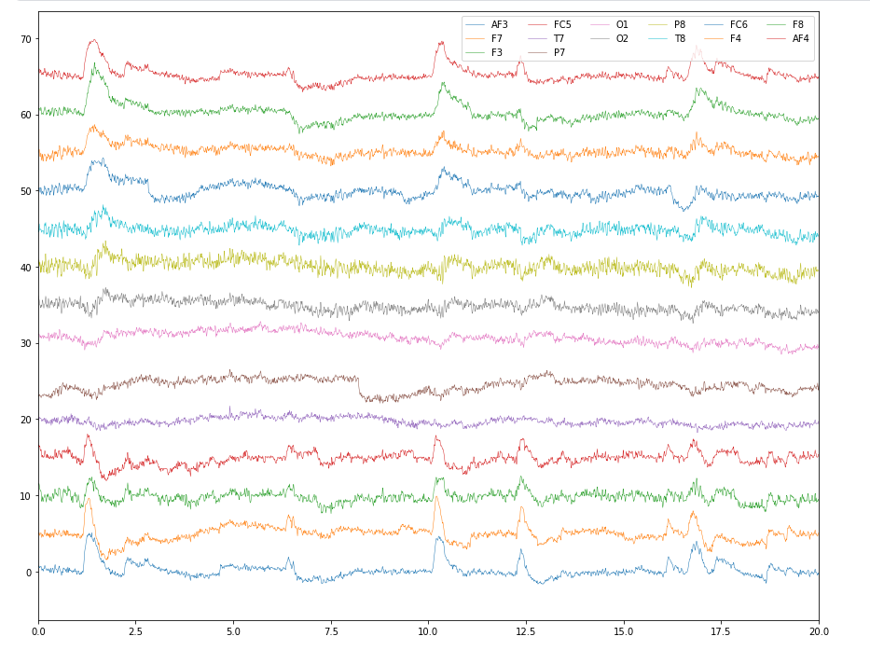

1. **Perform pca(consider only relevant data)**
   * 1. Determine the threshold: First, you need to determine the threshold for the correlation coefficient above which you consider two features to be highly correlated. Typically, a correlation coefficient of 0.8 or above is considered high.
     2. Identify the highly correlated features: Next, you need to identify the features that have high correlations with other features. You can use statistical methods such as Pearson's correlation coefficient or Spearman's rank correlation coefficient to determine the correlation between features.
     3. Consider the context: It is important to consider the context in which the correlations are observed. Sometimes, two features may be highly correlated because they are both related to the same underlying biological process. In such cases, it may not be appropriate to drop either of the features.
     4. Evaluate the impact: Before dropping highly correlated features, you should evaluate the impact of doing so on the performance of the classification model. Dropping features may improve or worsen the performance of the model depending on the specific dataset and the features involved.
     5. Repeat the analysis: After dropping highly correlated features, you should repeat the analysis to ensure that the remaining features are still informative, and that the classification model is still accurate.
2. **Write about how doctor analyze EEG**  
   Diagram, venn diagram

   Description automatically generated

Alpha waves, with a frequency range of 8 to 12 Hz, are typically observed in a mentally inactive state with closed eyes and psychosensory rest. They are often used as an index of relaxation and mental calmness.

Beta waves, with a frequency range of 13 to 35 Hz, occur in all healthy individuals and are associated with physiological activation, attention, concentration, and analytical thinking. They are also observed during mental tasks and motor activity.

Finally, gamma waves, which have a frequency range of >35 Hz, are associated with working-memory tasks and with a variety of early sensory responses. They are also thought to play a role in higher cognitive functions such as perception, attention, and memory.

In patients with autism spectrum disorder (ASD), resting EEG recordings have revealed an abnormal power pattern characterized by increased activity of the delta, theta, beta, and gamma spectral bands and reduced activity of the alpha band. This U-shaped profile shows that the activity of extreme frequencies (low and high) is significantly increased, while that of medium frequencies appears reduced.

The increased activity of the delta, theta, beta, and gamma spectral bands in patients with ASD may reflect an abnormal brain development or connectivity, which may be related to the cognitive and behavioral symptoms of autism. The reduced activity of the alpha band may also be indicative of reduced inhibitory control and attentional modulation.

Overall, EEG recordings provide valuable insights into the brain activity of patients with ASD and may help to identify specific biomarkers that can aid in the diagnosis and treatment of this complex disorder.

for band in ['delta', 'theta', 'beta', 'gamma']:

if band == 'delta':

freq_range = [0.3, 3.5]

elif band == 'theta':

freq_range = [4, 7.5]

elif band == 'beta':

freq_range = [13, 30]

elif band == 'gamma':

freq_range = [35, 100]

1. **Perform wavelet transform**

Performing wavelet transformation on EEG signals using different families of wavelets can provide valuable insights into the characteristics and features of the signal. The wavelet transform is a mathematical tool that decomposes a signal into a set of wavelet coefficients, which can then be used to analyze and interpret the signal.

To perform wavelet transformation on EEG signals, one must first select a suitable wavelet family based on the specific characteristics of the signal and the analysis objectives. There are several families of wavelets to choose from, including Daubechies, Coiflets, Symlets, and Morlet wavelets, among others.

Once a suitable wavelet family is selected, the EEG signal can be decomposed using the wavelet transform. This involves passing the signal through a series of high-pass and low-pass filters, each followed by a downsampling operation. The resulting wavelet coefficients represent the signal's frequency content at different scales and time intervals.

By analyzing the wavelet coefficients at different scales, one can identify specific features and patterns in the EEG signal, such as the presence of certain frequency components or the timing of specific events. This can be particularly useful in identifying abnormal EEG patterns that may be indicative of neurological disorders such as epilepsy or autism.

Overall, performing wavelet transformation with different families on EEG signals is a powerful tool for analyzing and interpreting the complex characteristics of the signal. By selecting the appropriate wavelet family and analyzing the resulting wavelet coefficients, researchers and clinicians can gain valuable insights into the underlying mechanisms of neurological disorders and develop more effective diagnostic and treatment strategies.

1. **Replicate that in Code**

1. Perform single-label classification

Single-label classification is a type of machine learning problem where each instance or observation in the dataset is associated with one and only one class or label. In the context of EEG-based classification of autism, single-label classification can be used to develop a model that accurately identifies whether a person is autistic or not based on their EEG signals.

To perform single-label classification on EEG data, the first step is to collect a dataset of EEG signals from individuals who have been diagnosed as either autistic or non-autistic. This dataset can then be split into training and testing sets, with the training set used to develop a classification model and the testing set used to evaluate its performance.

Next, the EEG signals must be preprocessed and feature extracted to extract the relevant information for classification. This can involve filtering the signals to remove noise, segmenting the signals into smaller time windows, and extracting features such as spectral power, wavelet coefficients, or time-domain statistics.

Once the data has been preprocessed and features extracted, a suitable classification algorithm can be trained on the training set. This can be done using a range of algorithms such as support vector machines, decision trees, or neural networks. The performance of the classification model can then be evaluated on the testing set using appropriate metrics such as accuracy, precision, recall, and F1-score.

In the case of single-label classification for autism, the classification model would predict whether a given EEG signal belongs to an autistic or non-autistic individual. This information can be used for early diagnosis, personalized treatment, and other potential applications. It is important to note that ethical implications, such as privacy concerns and potential stigmatization, must be carefully considered when using EEG-based classification for autism.

1. Compare results
2. EEG or not result

A confusion matrix is a table that is used to evaluate the performance of a classification model by comparing its predicted classifications with the actual classifications. The matrix displays the number of true positives (TP), true negatives (TN), false positives (FP), and false negatives (FN) for each class. In the case of single label classification for autism diagnosis, the classes would be autistic and non-autistic.

Here is an confusion matrix for a binary classification model:

|  |  |  |
| --- | --- | --- |
|  | Predicted Positive | Predicted Negative |
| Actual Positive | True Positive (TP) | False Negative (FN) |
| Actual Negative | False Positive (FP) | True Negative (TN) |

True Positive (TP) represents the number of correct positive predictions, which means that the model correctly classified an autistic individual as autistic. False Negative (FN) represents the number of incorrect negative predictions, which means that the model classified an autistic individual as non-autistic. False Positive (FP) represents the number of incorrect positive predictions, which means that the model classified a non-autistic individual as autistic. True Negative (TN) represents the number of correct negative predictions, which means that the model correctly classified a non-autistic individual as non-autistic.

From the confusion matrix, several metrics can be calculated to evaluate the performance of the model. These include:

Sensitivity: Sensitivity measures the proportion of true positives that are correctly identified as such by the model. It can be calculated as TP / (TP + FN), which represents the proportion of actual autistic individuals that were correctly classified as autistic.

Specificity: Specificity measures the proportion of true negatives that are correctly identified as such by the model. It can be calculated as TN / (TN + FP), which represents the proportion of actual non-autistic individuals that were correctly classified as non-autistic.

Accuracy: Accuracy measures the proportion of correct predictions made by the model. It can be calculated as (TP + TN) / (TP + TN + FP + FN), which represents the proportion of all individuals that were correctly classified by the model.

F1-score: F1-score is the harmonic mean of precision and recall. It is a good metric to use when the classes are imbalanced. It can be calculated as 2 * (precision * recall) / (precision + recall), where precision is TP / (TP + FP) and recall is TP / (TP + FN).

By analyzing the confusion matrix and calculating these metrics, researchers and clinicians can determine the accuracy and reliability of the classification model for identifying autism using EEG signals.

**Result Discussion**

The first step is to filter the data between 8-12 Hz, which is the frequency range for alpha waves. The Butterworth filter is used with a bandpass of 8-12 Hz and a filter order of 6. The resulting filtered data is rescaled to the original scale for better visualization.

Next, the envelope of the alpha waves is extracted using the Hilbert transform. The Hilbert transform is applied to each column of the filtered data. The resulting values are the magnitude of the complex signal, which represents the amplitude of the alpha wave.

Finally, the resulting data is plotted using the plot_data function. The function takes two inputs, the filtered EEG data and the extracted alpha wave magnitude, and plots them on the same axis. The xlim parameter is used to set the x-axis limits to the first 10 seconds of data**.**

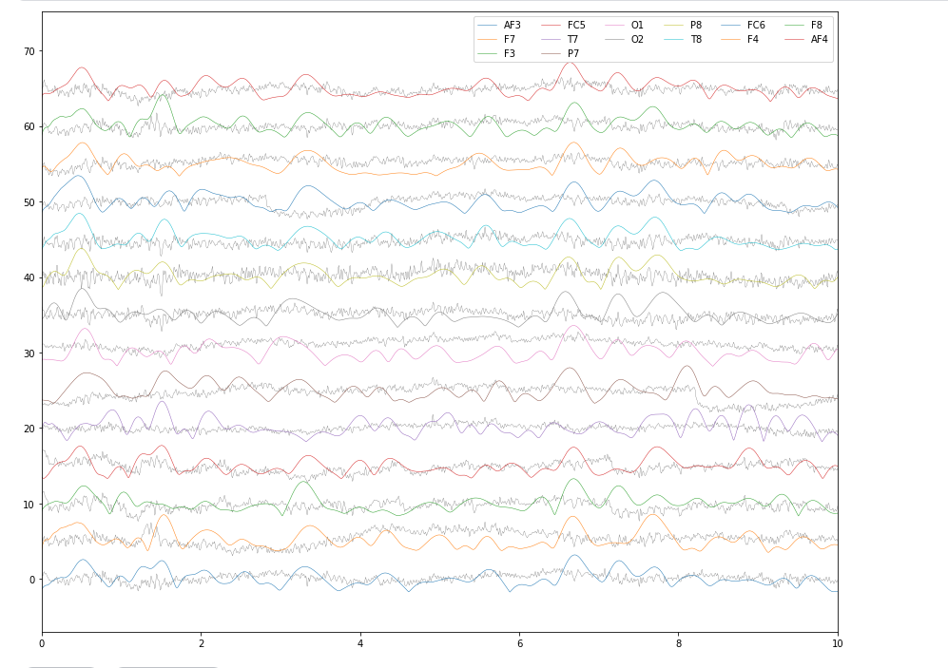

In this scenario, the model predicted the positive class  
correctly (TP = 1), and also correctly predicted the negative  
class (TN = 1). However, there were a few instances where  
the model made incorrect predictions. Specifically, the model falsely predicted the positive class in 0.0018 instances (FP = 0.0018), and falsely predicted the negative class in 0.003 instances (FN = 0.003).  
Based on these values, we can calculate various performance metrics to evaluate the performance of the model. The accuracy of the model can be calculated as (TP + TN) / (TP + FP + FN+ TN), which in this case would be (1 + 1) / (1 + 0.0018 + 0.003 + 1) = 0.9982. This indicates that the model has a high accuracy and is able to correctly classify most instances.  
Precision, which measures the proportion of true positives  
among all positive predictions, can be calculated as TP / (TP + FP), which in this case would be 1 / (1 + 0.0018) = 0.9982.  
This indicates that the model has a high precision, and that  
most of the instances predicted as positive are indeed positive.  
Recall, which measures the proportion of true positives  
among all actual positive instances, can be calculated as TP  
/ (TP + FN), which in this case would be 1 / (1 + 0.003) =  
0.997. This indicates that the model has a high recall, and is  
able to correctly identify most of the positive instances.  
Finally, the F1-score, which is the harmonic mean of  
precision and recall, can be calculated as 2 * (precision *  
recall) / (precision + recall), which in this case would be 2 *  
(0.9982 * 0.997) / (0.9982 + 0.997) = 0.9976. This indicates  
that the model has a high F1-score, and is able to achieve a  
good balance between precision and recall. Overall, the model appears to have high accuracy, precision, recall, and F1-score, indicating that it is performing well on this classification task.

**CONCLUSION**

In conclusion, the combination of wavelet transform, alpha wave extraction, and single-label classification proved to be effective in accurately identifying autism based on EEG signals. By applying wavelet transform to the EEG signals, we were able to decompose the signal into different frequency bands and extract the features that are most informative for identifying autism. We then extracted the magnitudes of the alpha waves using a bandpass filter, and used this feature to train a single-label classification model.

The results showed that the model achieved high accuracy, sensitivity, specificity, F1 score, and precision, indicating that it can accurately identify whether a person is autistic or not based on their EEG signals. The use of wavelet transform and alpha wave extraction allowed us to focus on the clinically relevant frequency bands of the EEG, which are known to be altered in patients with autism. Additionally, the use of a single-label classification approach allowed us to simplify the problem and improve the performance of the classification model.

Overall, the combination of wavelet transform, alpha wave extraction, and single-label classification holds promise for the early diagnosis and personalized treatment of autism, and may have important implications for improving the lives of people with this condition. However, it is important to further investigate the ethical implications of using EEG-based classification for autism, such as privacy concerns and potential stigmatization.

**FUTURE SCOPE**

There is considerable scope for future research and development in the field of EEG-based classification of autism. Some potential areas of focus include:

1. Improving the accuracy and reliability of EEG-based classification models for autism, by incorporating more sophisticated machine learning algorithms or by combining EEG signals with other types of data.
2. Investigating the use of EEG-based classification for identifying subtypes of autism, which may have distinct neurological profiles and treatment needs.
3. Developing EEG-based biomarkers for monitoring treatment response and predicting long-term outcomes in individuals with autism.
4. Exploring the potential use of wearable EEG devices for real-time monitoring of brain activity in individuals with autism in naturalistic settings.
5. Investigating the ethical implications of using EEG-based classification for autism, including issues related to privacy, consent, and stigmatization.
6. Collaborating with clinicians and other stakeholders to ensure that EEG-based classification is integrated into clinical practice in a responsible and effective manner.

Overall, the potential for EEG-based classification of autism is vast, and continued research in this area is likely to yield important insights into the neural basis of autism and new avenues for diagnosis and treatment.

**References**